**Unit #5**

**Score**: **_______ / _______**

**N-Gen Math 7**

**Multiple Choice Questions – Answer each of the following questions by picking the choice you believe correctly answers the question.**

1. Which of the following is not true?

(1) 

(2) 

(3) 

(4) 

2. Which of the following is the value of the expression  when ?

(1)  (3) 

(2) 28 (4) 72

3. Evie rewrote the expression  as . This is an example of Evie using which of the following properties?

(1) the associative property of addition

(2) the commutative property of addition

(3) the distributive property

(4) the addition property of equality

4. Which expression below is equivalent to ?

(1) 

(2) 

(3) 

(4) 

5. For the expression , which of the following is the coefficient of the term involving the variable *x*?

(1)  (3) 3

(2) 2 (4) 

6. Which of the following is *not* equivalent to ?

(1) 

(2) 

(3) 

(4) 

7. Which expression below is equivalent to ?

(1) 

(2) 

(3) 

(4) 

8. Carmen is receiving a raise of 6% on her salary. In order to directly calculate her new salary, she can multiply her old salary by which of the following?

(1) 6

(2) 

(3) 1.06

(4) 1.6

**Free Response Questions – Answer each of the following questions. Show the work you do in finding your final answer.**

9. Jayden correctly simplifies the expression  using the following steps. For each step, write the property that justifies it.

Step #1:  Property: _____________________________________

Step #2:  Property: _____________________________________

Step #3:  Property: _____________________________________

10. Write the following expression in simplest form:



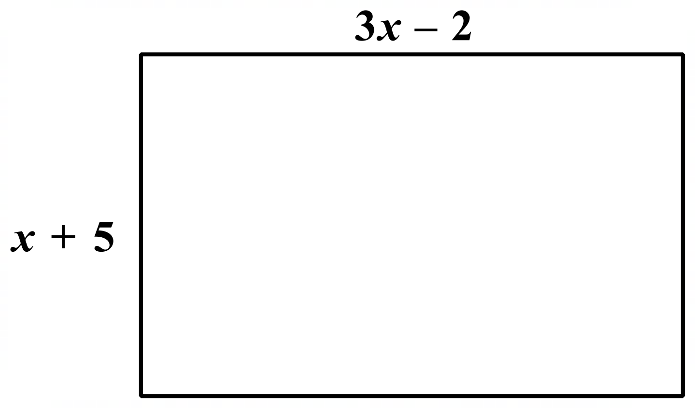

11. Write the perimeter of the rectangle shown in simplest terms of *x*.

12. Niko is buying a shirt that was originally $25, but is on sale for 15% off its original price. Niko will be charged an 7.5% tax on the shirt after the discount has been applied. What is the final amount Niko will be charged for the shirt? Show your calculations.